**CA2020 Bootcamp**

Farhana Akter

Location: Virginia, USA

Status: GC Holder



**Introduction to Web Development**

**TASK 01:**

* Install IDE (Microsoft Visual Code)
* Run a sample code from IDE
* Run the same program without using any IDE just CLI.
* Basic setup on local

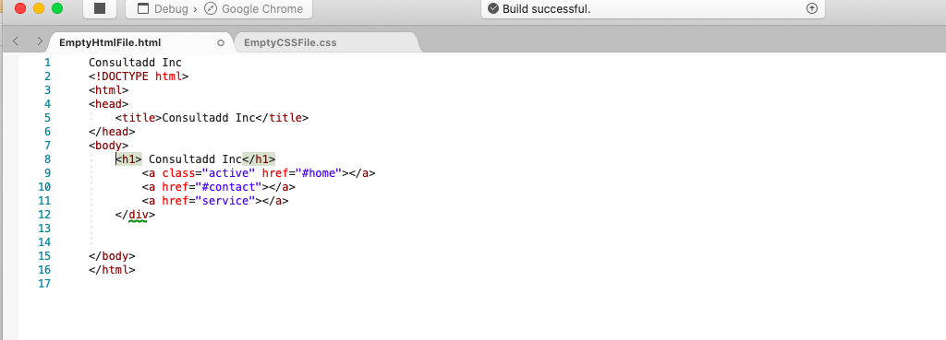

**TASK 02:**

* Create your first Login page
* Add following fields:

- Email Address

- Password

- Promocode

* Add CSS Background
* Add the logo of consultadd on top of the login page.
* Make sure to put the logo on the top left corner.



**TASK 03:**

Upload the code file on GitHub with a new repository (BOOTCAMP_HTML_TASK)

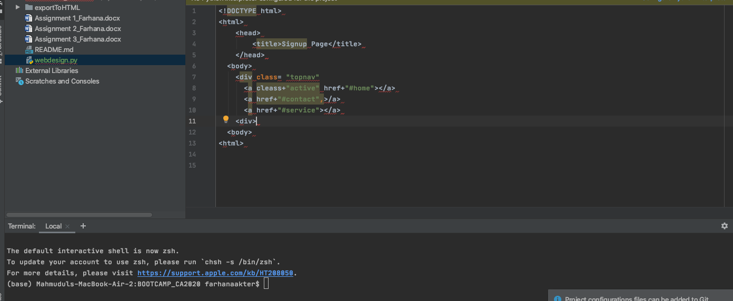

https://github.com/fakter777/BOOTCAMP_HTML_TASK.git